SVD Implementation of Zeroth-Order Tikhonov Regularization
Xiao Liang
University of Texas at Dallas

Synopsis
The method of zeroth-order Tikhonov regularization by SVD for stabilizing inverse problem solutions is introduced and used in three types of examples. L-curve criteria is introduced and presented for selecting an appropriate regularization parameter λ.

1. Selecting good solutions to ill-posed problems
We know that the SVD method can become extremely unstable when one or more of the singular values, 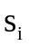, is small. One approach for dealing with this difficulty is the TSVD method. But the cost of this stabilized approach is that the regularized solution has reduced resolution and is no longer unbiased. Another widely applied and easily implemented technique for regularizing discrete ill-posed problems is Tikhonov regularization. The Tikhonov series solution has coefficients that are functions of the regularization parameter controlling the degree of

regularization, which gives greater weight to the model elements associated with larger singular values.
For a general linear least squares problem there may be infinitely many least squares solutions. If we consider that the data contains noise, and that there is no point in fitting such noise exactly, it becomes evident that there can be many solutions that can adequately fit the data in the sense that 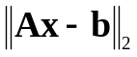 is sufficiently small. In zeroth-order Tikhonov regularization, we consider the damped least squares problem
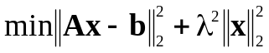, (1.1)
where λ is a regularized parameter. As λ increases, the set of feasible models expands, and the minimum value of 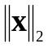 decreases. In other words, as we allow a poorer fit to the data, a smaller norm model will suffice to fit the data. We can thus trace out a curve of minimum values of .
Regularization is necessary when solving inverse problems because the “naive” least squares solution, formally given by 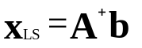, is completely dominated by contributions from data errors and rounding errors. By adding regularization we are able to damp these contributions and keep the norm of reasonable size. This philosophy underlies Tikhonov regularization and most other regularization methods.
Note that if too much regularization, or damping, is imposed on the solution, then it will not ﬁt the given data b properly and the residual 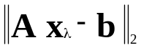 will be

too large. On the other hand, if too little regularization is imposed then the ﬁt will be good but the solution will be dominated by the contributions from the data errors, and hence 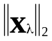, will be too large. Figure 1.1 illustrates this point for Tikhono regularization.
Having realized the important roles played by the norms of the solution and the residual, it is quite natural to plot these two quantities versus each other, i.e., as a curve
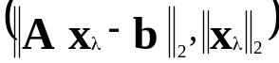 (1.2)
parameterized by the regularization parameter. This is precisely the L-curve; see Figure 1.2 for an example. Hence, the L-curve is really a trade off curve between two quantities that both should be controlled.

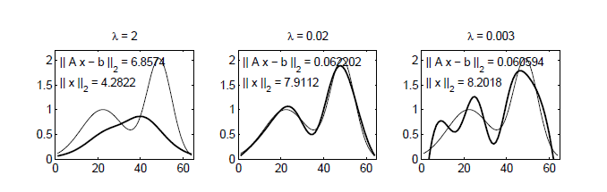
Figure 1.1 : The exact solution (thin lines) and Tikhonov regularized solutions 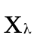 (thick lines) for three values of λ corresponding to over-smoothing, appropriate smoothing, and under-smoothing.

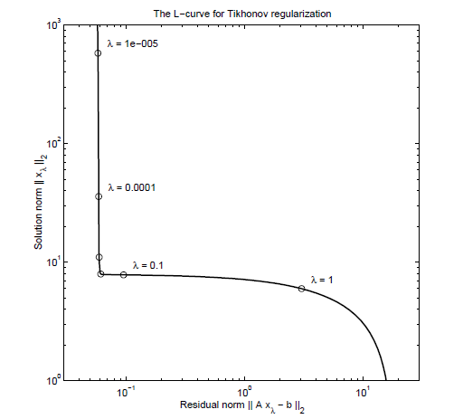
Figure 1.2 : The generic L-curve for standard-form Tikhonov regularization; the points marked by the circles correspond to the regularization parameters 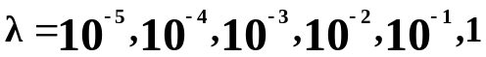.

When plotted on a log–log scale, the curve of optimal values of versus often takes on a characteristic “L” shape in linear problems. This happens because is a strictly decreasing function of λ and is a strictly increasing function of λ. The sharpness of the “corner” varies from problem to problem, but it is frequently well-defined. A popular criterion for picking the value of λ is the L-curve criterion, in which the value of λ that gives the solution closest to the corner of the L-curve is selected.

2. SVD implementation of Tikhonov regularization
The damped least squares problem is equivalent to the ordinary least squares problem obtained by augmenting the least squares problem for Ax = b in the following manner :
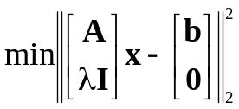 (2.1)
As long as λ is nonzero, the last n rows of the augmented matrix in (2.1) are obviously linearly independent. Equation (2.1) is thus a full rank least squares problem that can be solved by the method of normal equations, that is,
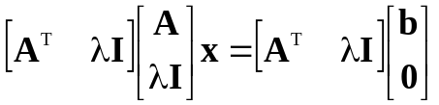 (2.2)
Equation (4) simplifies to
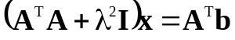 (2.3)
which is the set of constraint equations for a zeroth-order Tikhonov regularization solution of Ax = b.
Employing the SVD of A, (2.3) can be written as
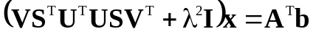 (2.4)
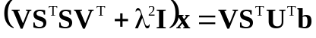 (2.5)
A simple substitution diagonalizes this system of equations and makes it
straightforward to write out the solution. Let 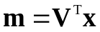 and x=Vm. Since 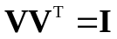, we can write (2.5) as
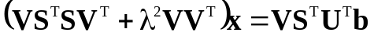 (2.6)

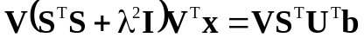 (2.7)
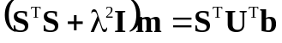 (2.8)
The matrix on the left-hand side of this equation is diagonal, so it is trivial to solve the system of equations,
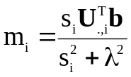 (2.9)
Since x=Vm, we obtain the solution
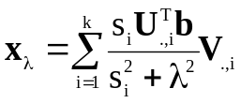 (2.10)
where k = min(m, n) so that all of the nonzero singular values and vectors are included. We can rewrite it slightly as
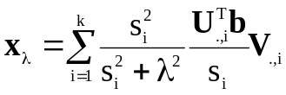 (2.11) or
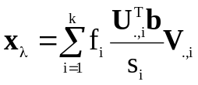 (2.12)
Here, the filter factors
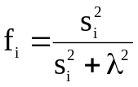 (2.13)

3. When the L-curve is concave or convex
The L-curve corresponds to the noisy right-hand side 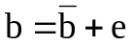. Depending on λ, it is either the noise-free components or the pure-noise components that dominate, and the resulting L-curve therefore essentially consists of one “leg” from the unperturbed L-curve and one “leg” from the pure-noise L-curve. Somewhere in between, there is a range of λ-values that correspond to a transition between the two domination L-curves. An exact right-hand side that satisfies the Discrete Picard Condition, or a right-hand side e corresponding to pure white noise, leads to an L-curve that is concave when plotted in a log-log scale. However there are also some cases that the L-curve is convex. In a log-log scale, the L-curve for the unperturbed problem is overall flat at 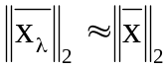, except for large values of the residual norm 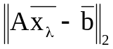 where the curve approaches the axis. In a linear scale, the L-curve is always convex, independently of the right-hand side. The logarithmic scale, on the other hand, emphasizes the difference between the L-curves for an exact right-hand side and for pure noise e, and it also emphasizes the two different parts of the L-curve for a noisy right-hand side .

4.The curvature of the concave L-curve
The curvature of the L-curve plays an important role in understanding the L-curve. In this section we shall therefore derive a convenient expression for this curvature. Let
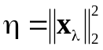, 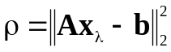 (4.1)
and
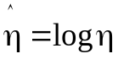, 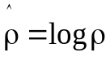 (4.2)
such that the L-curve is a plot of η/2 versus ρ/2, and recall that η and ρ are functions of λ. Moreover, let 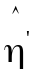, 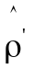, 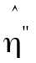 and 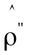 denote the ﬁrst and second derivatives of η and ρ with respect to λ. Then the curvature κ of the L-curve, as a function of λ, is given by
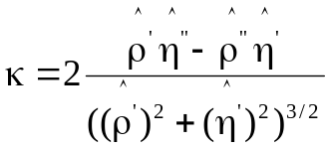 (4.3)
The goal is now to derive a more insightful expression for κ. The ﬁrst step is to derive expressions for the derivatives of η and ρ with respect to λ. These derivatives are called the logarithmic derivatives of η and ρ, and they are given by
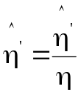 and 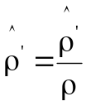 (4.4)
The derivatives of η and ρ, in turn, are given by
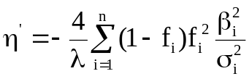 and 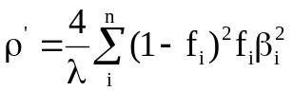 (4.5)

where 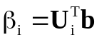. These expressions follow from the relations
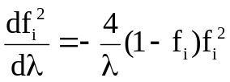 and 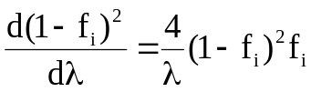 (4.6)
Now using the fact that
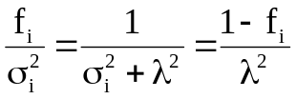 (4.7)
We arrive at the important relation
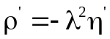 (4.8)
The next step involves the computation of the second derivatives of and with respect to λ, given by
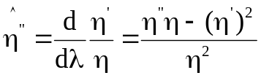 and 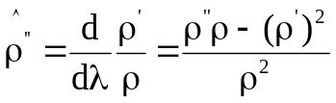 (4.9)
It suffices to consider the quality
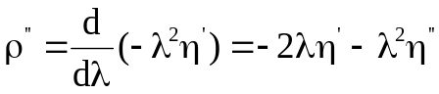 (4.10)
When we insert all the expressions for , , , and into the formula for κ and make use of (4.8) and (4.10), then both 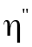 and 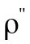 as well as 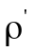 vanish, and we end up with the following expression
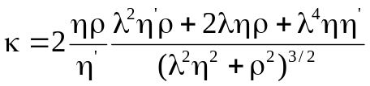 (4.11)
where the quantity 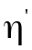 is given by (4.5).
The rationale behind this choice is that the corner separates the ﬂat and vertical parts of the curve where the solution is dominated by regularization errors and perturbation errors, respectively. We note that this so-called L-curve criterion for

choosing the regularization parameter is one of the few current methods that involve both the residual norm and the solution norm .
In order to provide a strict mathematical definition of the “corner” of the L-curve, we use the point on the L-curve 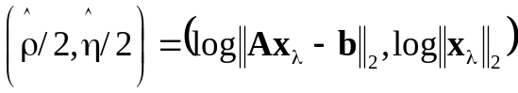 with maximum curvature κ given by Equation (4.10).
Figure 4.1 illustrates the L-curve criterion: the left part of the figure shows the L-curve, where the corner is clearly visible, and the right part shows the curvature κ of the L-curve as a function of λ. The sharp peak in the κ-curve corresponds to the sharp corner on the L-curve.

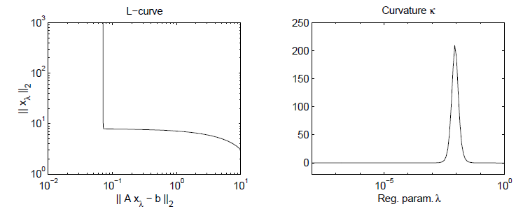
Figure 4.1 : A typical L-curve (left) and a plot (right) of corresponding curvature κ as a function of the regularization parameter.

5. Examples 1: Ballistic regression
Suppose we are given a model of linear regression of ballistic observation to a quadratic model, where the regression model is
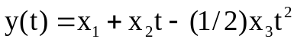 (5.1)
Here y is measured in the upward direction, and the minus sign is applied to the third term because gravitational acceleration is downward. Consider a synthetic data set with m=20 observations and independent normal data errors (σ=8m), generated using
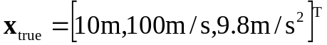 (5.2)
To obtain the least squares solution, we construct the A matrix. The ith row of A is given by
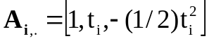 (5.3)

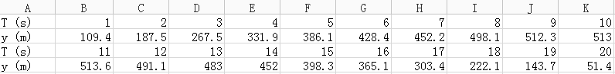
Table 5.1 Data for the ballistics example.

We begin by computing the L-curve at 1000 points and try to find the corner by estimating the point of computing the L curve. Figure 4.1 shows the L-curve. In this example, the L-curve is convex, which means that the flat part is dominated by unperturbed data, while the quickly decayed part is dominated by the noise. So

picking out the corner of the L-curve is not suitable in this example. If which pick out the corner of the L-curve corresponding to the maximum curvature 0.7062, the regularization parameter is 13.4896 and the calculated 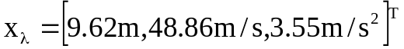 which is not close to the true model.
Instead, we need to pick out x information from the flat part of the L-curve, because this part is controlled by the unperturbed data. Looking at the x value corresponding to curvature near zero, they are almost 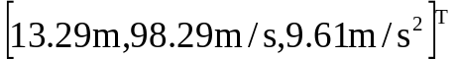, which is closer to 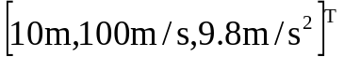 compared with the data picking from the maximum curvature. See Table 5.2.

Figure 5.1 Zeroth-order Tikhonov regularization L-curve for the ballistic problem (left picture). The curvature of the the L-curve (right picture).

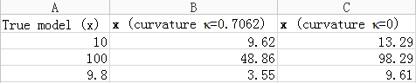
Table 5.2 x value of the true model, the corner of the L-curve and the flat part of the L-curve.

6. Example 2: Instrument impulse response
Consider an inverse problem where we have a physical process (e.g., seismic ground motion) recorded by a linear instrument of limited bandwidth (e.g., a vertical seismometer; figure 6.1). The response of such a device is commonly characterized by an instrument impulse response, which is the response of the system to a delta function input. Consider the instrument impulse response
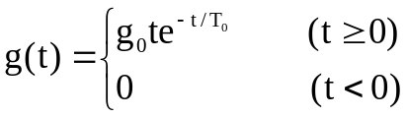 (6.1)
Figure 6.1 shows the displacement response of a critically damped seismometer with a characteristic time constant 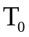 and gain, 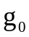, to a unit area 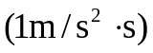 impulsive ground acceleration input.

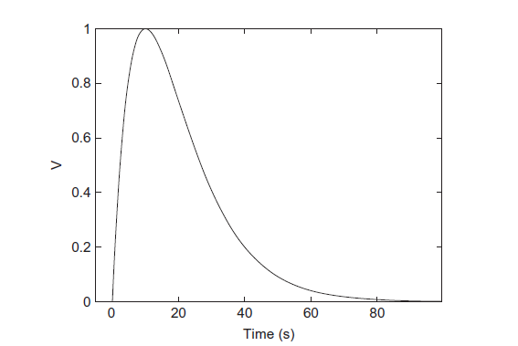
Figure 6.1 Example instrument response; seismometer output voltage in response to a unit area ground acceleration impulse (delta function).

Assuming that the displacement of the seismometer is electronically converted to output volts, we conveniently choose to be 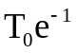V/m · s to produce a 1-V maximum output value for the impulse response, and = 10 s.
The seismometer output (or seismogram), v(t), is a voltage record given by the convolution of the true ground acceleration, 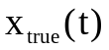, with (6.1)
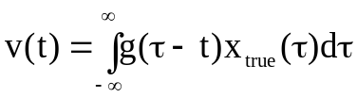 (6.2)
We are interested in the inverse deconvolution operation that will remove the smoothing effect of g(t) in (6.2) and allow us to recover the true ground acceleration 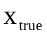.
Discretizing (6.2) using the midpoint rule with a time interval 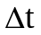, we obtain

b=Ax (6.3)
where
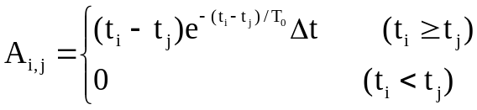 (6.4)
The rows of A in (6.4) are time-reversed, and the columns of G are non–time-reversed, sampled representations of the impulse response g(t), lagged by i and j, respectively. Using a time interval of [−5, 100] s, outside of which (6.1) and any model, m, of interest are assumed to be very small or zero, and a discretization interval of =0.5s, we obtain a discretized m by n system matrix A with m = n = 210.
Now, consider a true ground acceleration signal that consists of two acceleration pulses with widths of σ = 2s, centered at t = 8s and t = 25s
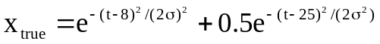 (6.5)
We sample 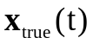 on the time interval [−5, 100] s to obtain a 210-element vector 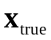 (see figure 6.2), and generate the noise-free data set
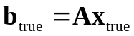 (6.7)
and a second data set with independent 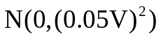 noise added. The data set with noise is shown in Figure 6.4. And the predicted data without noise is shown in Figure 6.3.

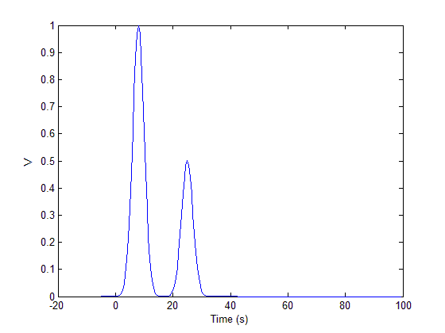
Figure 6.2 The true model.

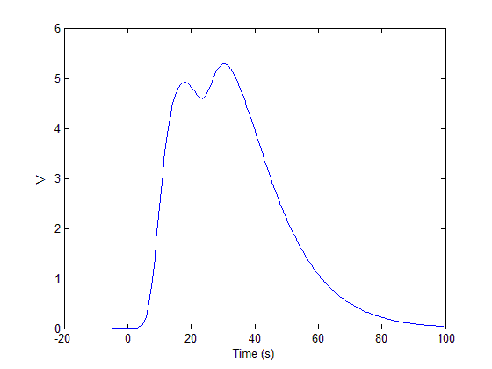
Figure 6.3 The predicted data set without noise.

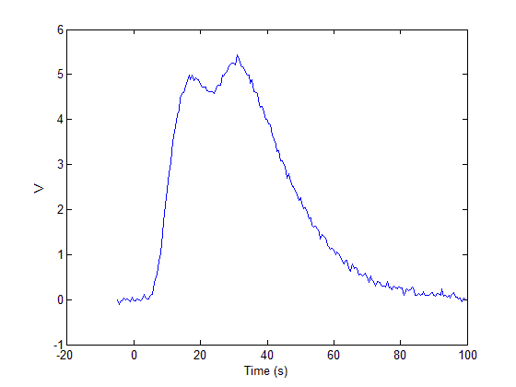
Figure 6.4 Predicted data from the true model plus independent 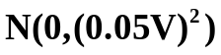 noise.

First we need to use Zeroth-order Tikhonov regularization to plot the L-curve in order to pick out the appropriate regularization parameter λ. The L-curve and its curvature are shown in Figure 6.5
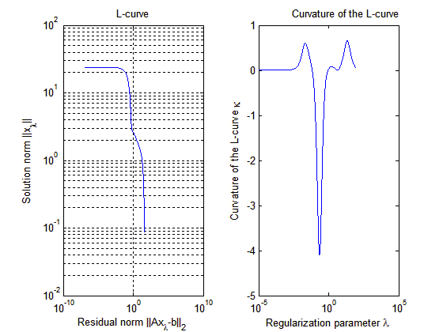
Figure 6.5 Zeroth-order Tikhonov regularization L-curve for the instrument impulse response problem, and the curvature of the L-curve.

The corner of the L-curve is at (0.5677, 2.9749) corresponding to the maximum 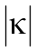=4.09. At this corner, the regularization parameter λ=0.2188. The zeroth-order Tikhonov regularization solution of this problem is shown in figure 6.6.

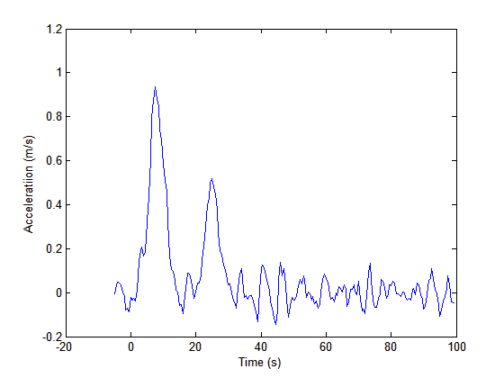
Figure 6.6 Solution from zeroth-order Tikhonov regularization with L-curve corner estimated by using maximum absolute curvature.

7.Example 3: Shaw problem
A classic pedagogical inverse problem is an experiment in which an angular distribution of illumination passes through a thin slit and produces a diffraction pattern, for which the intensity is observed (Figure 7.1).
The data, b(s), are measurements of diffracted light intensity as a function of the outgoing angle −π/2 ≤ s ≤ π/2. Our goal is to find the intensity of the incident light on the slit, m(θ), as a function of the incoming angle −π/2 ≤ θ ≤ π/2. The forward problem relating d and m can be expressed as the linear mathematical model,
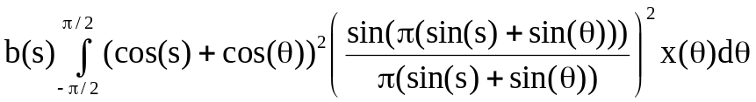 (7.1)

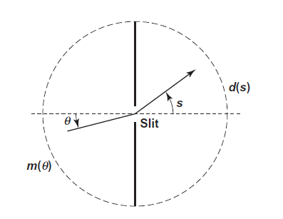
Figure 7.1 The Shaw diffraction intensity problem (7.1).

To discretize the Shaw problem (7.1), we apply the method of simple collocation with m and n intervals for the data and model functions, respectively. We additionally define the data and model points at m and n equally spaced respective angles given by
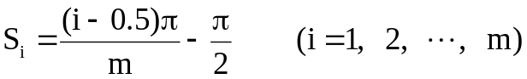 (7.2)
and
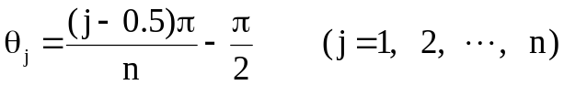 (7.3)
Correspondingly, discretizing the data and model into m- and n-length vectors
(7.4)
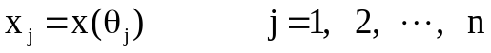 (7.5)
leads to a discrete linear system Ax= b, where
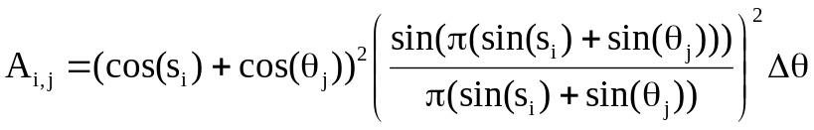 (7.6)
and
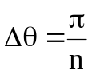 (7.7)
The true model in this example is a spike of unit amplitude in the 10th model element, and independent 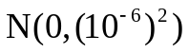 noise has been added to the data vector.
We begin by computing the L-curve at 1000 points and finding its corner by estimating the point of maximum curvature. Figure 7.2 shows the L-curve and its curvature. The corner of the curve corresponds to λ ≈ 5.75 × 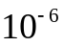. Next, we

compute the Tikhonov regularization solution corresponding to this value of λ. This solution is shown in Figure 7.3

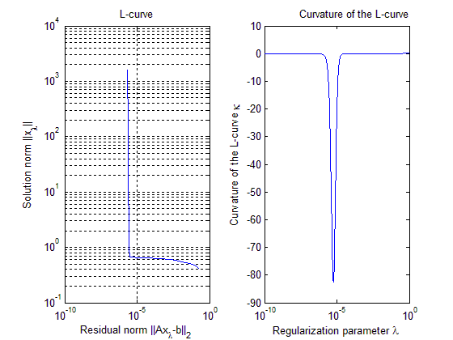
Figure 7.2 Zeroth-order Tikhonov regularization L-curve for the Shaw problem, with corner estimated using maximum functional curvature.

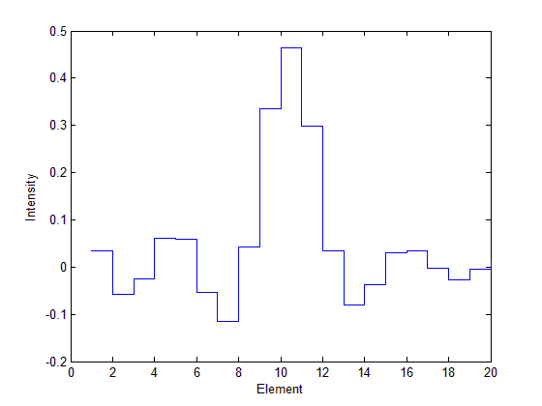
Figure 7.3 Recovery of the spike model with noise, zeroth-order Tikhonov solution (λ = 5.75 × 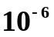 determined from the L-curve corner).

8. Limitations of the L-curve criterion
Every practical method has its disadvantages. There are two disadvantages of the L-curve criterion. Understanding these limitations is a key to the proper use of the L-curve criterion and, hopefully, also to future improvements of the method.
The first limitation is concerned with the reconstruction of very smooth exact solutions, i.e., solutions x for which the corresponding SVD coefficient 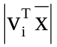 decays quickly to zero, such that the solution x is dominated by the first few SVD components. For such solutions, the L-curve criterion will fail, and the smoother the solution (i.e., the faster the decay) the worse the λ computed by the L-curve criterion.
The second limitation of the L-curve criterion is related to its asymptotic behavior as the problem size n increases. The regularization parameter 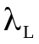 computed by the L-curve criterion may not behave consistently with the optimal parameter 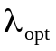 as n increases.
But the L-curve criterion is still widely used because it is robust and able to treat perturbations consisting of correlated noise.

9. Conclusions
In the method of zeroth-order Tikhonov regularization, the L-curve criterion and its curvature are plotted to identify the corner of the L-curve and the corresponding regularization parameter λ. This paper points out that the L-curve not only exists in the concave situation, but also has a convex condition which means that concave and convex L-curves need to be considered differently when picking out the proper position according to the curvature. The calculated solution 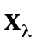using the L-curve criterion is reasonably close to . But there are two limitations of the L-curve criterion, which are concerned with the reconstruction of very smooth exact solutions and its asymptotic behavior as the problem size n increases.

- References

1. Richard C. Aster, Brian Borchers and Clifford H. Thurber, Parameter Estimation and Inverse Problems, Second Edition, 2013, Elsevier.

2. P. C. Hansen, The L-curve and its Use in the Numerical Treatment of Inverse Problem, In in Computational Inverse Problems in Electrocardiology, ed. P. Johnston, Advances in Computational Bioengineering, Vol. 4 (2000), pp. 119-142.

